1. **The Privacy Act 2020**

* New Zealand’s Privacy Act 2020 needs you to inform users about your website’s use of cookies and its processing of personal information.
* A Website Privacy Policy is a document that sets out the rules and processes a business must follow when dealing with its customers’ personal information which provides comfort to customers that their personal information is being dealt with in accordance with the law.
* Nobody can transfer of personal information outside of New Zealand under the principle guidelines in NZ Privacy Act 2020.
* Fines for non-compliance with the NZ Privacy Act and NZ Privacy Principles can reach $10,000.
* NZ Privacy Act 2020 is enforced by the Office of the Privacy Commissioner.

**Cookies, trackers and the NZ Privacy Act 2020**

Cookies and trackers are the most common way for websites to process personal information.

Most websites in the world process data that is defined as *personal*, meaning data that is able to identify a living person, either directly or indirectly through inference.

Cookies and trackers can be hard to difficult to detect and control without any assisting technology, especially considering that –

**72% of cookies** are hidden inside other cookies – also known as trojan horses.

**18% of cookies** hide even deeper inside other hidden cookies, sometimes loaded by eight other cookies.

**50% of trojan horses** will have changed upon repeated visits by users.

### **The 13 NZ Privacy Principles:**

New Zealand’s Privacy Act 2020 allows under **13 Privacy Principles and** they have arranged together to **form a map of the legal way** to collect, process, share, store the personal information of users located inside New Zealand.

The 13 Privacy Principles are –

1. Purpose for collection
2. Source of information
3. What to tell an individual
4. Manner of collection
5. Storage and security
6. Access
7. Correction
8. Accuracy
9. Retention
10. Use
11. Disclosure
12. Disclosure outside New Zealand
13. Unique identifiers

NZ privacy principle 3 is applicable for website owners and operators has to aware of the law such as, websites most often collect and process personal information from their visitors through cookies and trackers embedded on their domain via analytics software, marketing services or social media integrations.

If your website is in contact with such data [through its cookies and trackers](https://www.cookiebot.com/en/website-tracking), **you are required by New Zealand’s Privacy Act 2020 and its NZ Privacy Principles** to notify users before collection and inform them of what, why and who you share it with.

Using Cookiebot CMP takes all the hard work out of data privacy law compliance by offering plug-and-play compliance with New Zealand’s Privacy Act 2020 – and a host of other major data laws like [EU’s GDPR](https://www.cookiebot.com/en/gdpr), [California’ CCPA](https://www.cookiebot.com/en/ccpa), [Brazil’s LGPD](https://www.cookiebot.com/en/lgpd), [South Africa’s POPIA](https://www.cookiebot.com/en/popia) and more.

1. **intellectual Property and Copyright**

Copyright is the legal right to control the reproduction/copying of an original work.

Copyright is an intellectual property right. In New Zealand, copyright does not require registration because it is automatically attributed to the creator. Copyright is different for numerous organisations, which is very important in every sector.

[The Copyright Act (1994)](http://www.legislation.govt.nz/act/public/1994/0143/latest/DLM345634.html) governs copyright in New Zealand, defining the duration of copyright, copyright holders, which rights can be reassigned or traded, and what is deemed infringement. Copyright laws vary overseas.

Creating or interacting with copies of an original work is an inevitable component of working in the cultural heritage sector. These interactions are usually for in-house purposes including: catalogues, marketing, reproductions for exhibitions, or even external requests from visitors for a digital copy of an item.

**Copyright is not covering below things such as -**

* Intangible ideas
* Facts
* Natural objects
* Copyright is distinct from moral or ethical rights which should still be considered when reproducing works.
* Notably, [mātauranga Māori](https://www.iponz.govt.nz/about-ip/maori-ip/) (Māori knowledge in relation to cultural customs) should be taken into account when reproducing taonga and should be done so collaboratively with local iwi and / or hapū representatives.

**Listed below eligible people who can own copyright -**

Unless agreed to otherwise:

* Creator(s) in the first instance.
* The Commissioner of the work.
* Employer (where an employee creates the work).
* Joint ownership: just as there can be different types of media within one work, there can also be multiple creators, and this means there are sometimes multiple copyright holders as well. There are number of types of holders which are applicable for their circumstances.

Examples of works that may have multiple copyright holders:

* An illustrated book could have copyright attributed to the publisher, author, and the illustrator.
* Publications with joint authors and editors.
* Audio-visual works – producer and director.
* Music – the record label, the recording artist(s), and collaborators.

## COPYRIGHT DURATION

Duration and ownership of copyright are separate. The duration that a work is in copyright is dependent on the type of work. The following table and infographic help to depict copyright duration in New Zealand as of 2019.

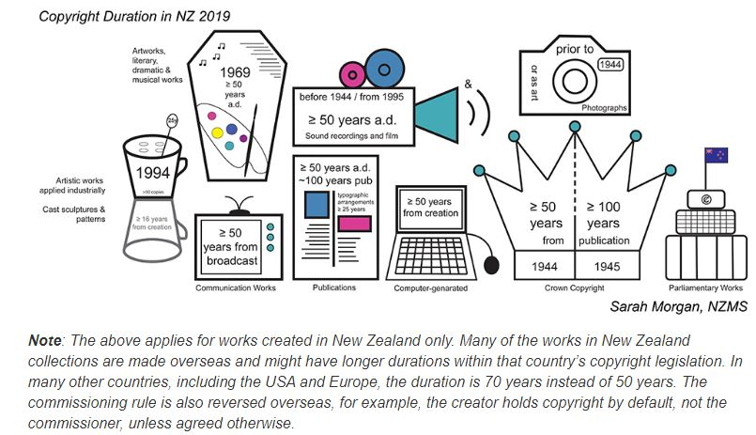

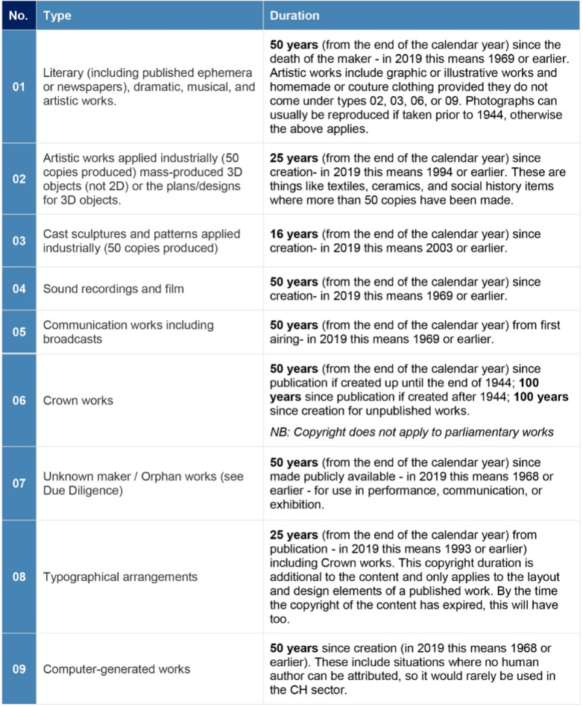

1. NZ’s Cyber Security strategy 2019

Cyber-crime is a mega-business worth billions of dollars. The cost and effort to combat attacks is increasing. Nothing is guaranteed and the work required to reduce your risk is rapidly evolving.

New tools, new processes and new staff awareness is required. The protections that seemed excessive a year ago are now inadequate. With the pace of change, tools and processes must be thoroughly reassessed every year.



Now-a-days, we all are totally dependent on the digital media which is easily accessible everywhere in the world. The benefits of these global connections will continue to increase. Being able to work, play and interact safely online is a critical enabler for our economic, social and cultural development – New Zealand is becoming a digital nation. As the benefits increase, so does our dependence on a free, open and secure internet and trusted underlying infrastructure and technology. Almost every aspect of our daily life now depends on the internet and information technology. This ranges from the basic functioning of New Zealand’s economy and society – from our jobs, banks, schools – to the delivery of government and telecommunications, and electricity services. While around 90% of New Zealand’s population are active internet users.

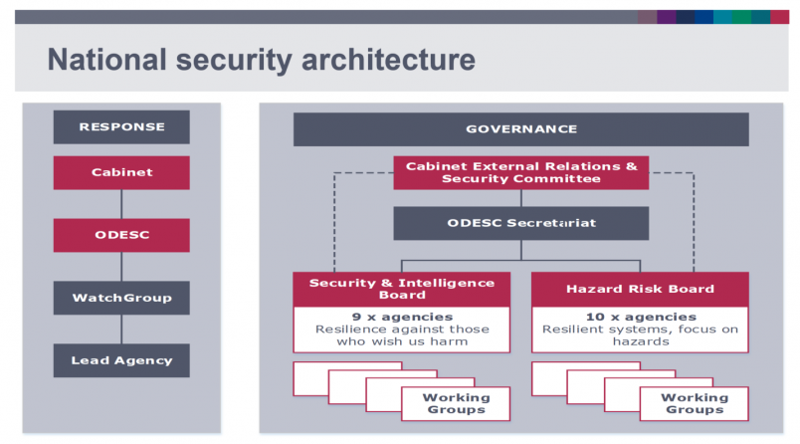

New Zealand’s cyber security policy is therefore about making the most of the opportunities that the internet provides and protecting the things most important to us. But with new opportunities come evolving cyber security risks. Artificial intelligence (AI) and cognitive technologies are becoming increasingly commonplace, along with a range of internet-connected everyday devices. The arrival of 5G wireless networks is close and quantum computing is on the horizon. These new technologies will be disruptive. That will allow NZ people to innovate, but may also expose to greater risk. These technological changes are not happening in a vacuum: the geopolitical picture has also shifted, with a greater range of state actors making the most of cyber-enabled tools to steal information, spread disinformation and launch attacks. New Zealand’s response to the evolving risk needs to be commensurate with our dependence on internet connectivity. This strategy emphasises that the government needs to work with individuals, businesses, community organisations and the private sector, in order to minimise harm and disruption, and make the most of technological advances.

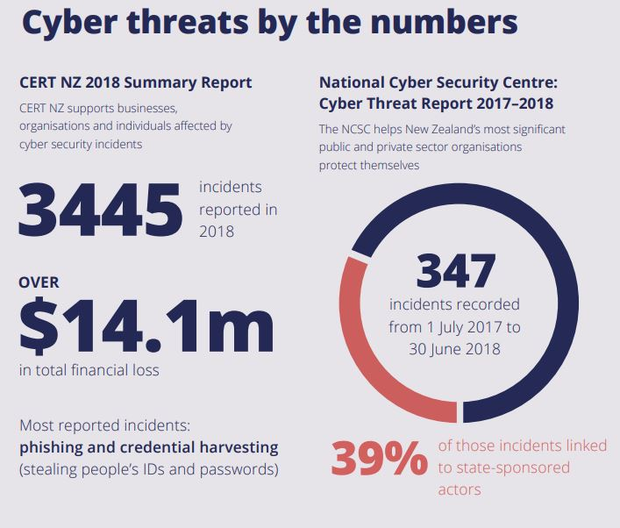

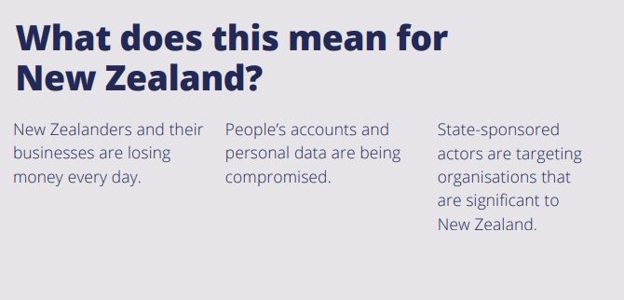

It is an opportunity for the New Zealand Government to take a lead in responding to cyber risks but also for us to achieve this vision as a nation. One of the priority areas in this strategy is to develop cyber security aware and active citizens. There are actions we can take collectively to reduce the risk for everyone, and responding to emerging issues requires everyone to take action: individuals, businesses, non-government organisations, and government. This strategy outlines the areas in which we will prioritise action and how we will work together.

1. **International Web Association Code of Ethics**

## International Web Association

Founded in 1996, IWA, a non-profit professional association, is the industry’s recognized leader in providing educational and certification standards for Web professionals. IWA’s initiatives now support more than 100 official chapters representing over 300,000 individual members in 106 countries. IWA’s accomplishments include the industry’s first guidelines for ethical and professional standards, Web certification and education programs, specialized employment resources, and technical assistance to individuals and businesses.

The International Web Association is an individual membership association organized solely for the benefit of its members. Members shall be dedicated to self-development, sharing ideas, and developing professional contacts. IWA members, in their professional conduct, shall be guided by IWA’s Standards of Professional Practices and a Code of Ethics to provide superior service to their employers and clients. Professional Development shall be the cornerstone of the IWA.

Recognizing the responsibility of the Web profession to the people and business of our global community believing that we should encourage and foster high ethical standards in our profession, we do hereby adopt the following Code of Ethics for our constant guidance and inspiration predicated upon the basic principles of truth, justice and fair play.

1. To show faith in the worthiness of our profession by industry, honesty, and courtesy, in order to merit a reputation for high quality of service and fair dealing.
2. To add to the knowledge of our profession by constant study and to share the lessons of our experience with our fellow members.
3. To build an ever increasing confidence and good will with the public and our employers by poise, self-restraint and constructive cooperation.
4. To conduct ourselves in the most ethical and competent manner when soliciting professional service or seeking employment, thus meriting confidence in our knowledge and integrity.
5. To accept our full share of responsibility in constructive public service to community, state, our nation and the global community.
6. To protect the intellectual property of others by relying on our own innovation and efforts, thus ensuring that all benefits vest with its originator.
7. To strive to attain and to express a sincerity of character that shall enrich our human contacts, ever aiming toward that ideal–“The Practice of the Golden Rule.”

# **IWA Industry Standards Partners**

IWA is a leading developer of industry standards in a broad-range of industries. Globally recognized, IWA is the grand partner with the famous international standard organizations such as W3C, ISO, CEN and UNESCO, participating in regulating international standardization.

[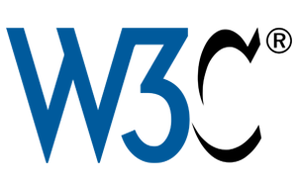](http://www.w3.org/)

##### **W3C.org**

The World Wide Web Consortium (W3C) develops interoperable technologies (specifications, guidelines, software, and tools) to lead the Web to its full potential. W3C is a forum for information, commerce, communication, and collective understanding.

[](http://www.iso.org/)

##### **ISO**

ISO (International Organization for Standardization) is the world’s largest developer of voluntary International Standards. International Standards give state of the art specifications for products, services and good practice, helping to make industry more efficient and effective. Developed through global consensus, they help to break down barriers to international trade.

[](http://www.unesco.org/)

##### **UNESCO**

The United Nations Educational, Scientific and Cultural Organization (UNESCO) was founded on 16 November 1945. For this specialized United Nations agency, it is not enough to build classrooms in devastated countries or to publish scientific breakthroughs.

1. **The Domain Name Commission**

The Domain Name Commission was appointed by InternetNZ to develop and monitor a competitive registrar market, as well as create a fair environment for the registration and management of .nz domain names.

Under the domain name commission they are:

##### Authorize and de-authorize providers

##### Authorize and de-authorize domain name providers. This is to ensure the best service possible for .nz domain name holders.

##### Contact centre

Field enquiries, questions and complaints about registrars and their compliance with .nz policies.

##### Validating registration information

Validate the registration information supplied for .nz domain names.

##### .nz Dispute Resolution Service (DRS)

Administer a free to file Dispute Resolution Service for disputes over who should be the registrant of a .nz domain name.

##### Compliance work

Adjudicate, mediate and facilitate the handling of disputes.

##### Market regulation

Deal with allegations of poor performance from service providers.

**Task 2**:

1. **You must write an analysis of your website’s use of images, text and multimedia and indicate how you have honoured NZ Copyright law.**

Analysis:

Under the copyright of New Zealand, I have create a new website for a gym.

As per the effective gym website requirement, we need a strong online presence is a must have for any gym business which I tried to serve in multiple ways. My website attracts everywhere, new members will view gym class. I have uploaded numbers of gym equipment images for the member convenience and also uploaded the videos about the simple ways of exercises or yoga. The special page of post for personal training and amenities gives additional attraction towards the website by just one click. The training page description tell visitors exactly what to expect and the site navigation is easy to use. I have designed the pages like About Us and Contact Us for easy to find the location and contact information, Email, hours of operation and the gym description. Also added high quality visual fresh content, professional quality images, dark mode, contracting colour combination, bold colours and fonts, request a call button etc.

1. **Explain the advantage of having your website be a .nz domain and the support available from the domain name commission?**

Advantages:

A domain name is an online address that offers a user-friendly way to access a website’s true online locator: it’s Internet Protocol (IP address).

Domain names consist of a unique name chosen by the user and an extension, such as .com, .net, or .org, that designates the site’s Top Level Domain.

Depending on the name you choose, buying and registering a domain name can cost as little as $10 USD or as much as thousands of dollars for a sought-after existing name. New, unusual TLDs like .me or .bio can cost more than the familiar .com or .net, too.

You should get a domain name because the online world is rich with opportunities to create a business or blog on free or paid hosting sites, or even on social media. Free Facebook pages and blogging platforms like BlogSpot or Medium allow users to claim a space for posting content and images of all kinds. Online marketplaces like Shopify and Etsy provide storefronts for entrepreneurs to sell physical and digital goods. Sites like Squarespace make it possible for creatives like photographers and designers to set up an online portfolio without creating a whole website from scratch. These sites demonstrate that it’s possible to have an online presence without owning your own domain. But if your aim is to be widely visible and build authority for your brand, these platforms and social media sites have considerable drawbacks—problems that can be avoided with the purchase of your very own domain name.

You should choice a domain name unique and searchable because, when you sign up for space on a third party website hosting site or create a page or account on your favourite social media platforms, you’ll typically be provided with a subdomain on the hosting site’s domain. Your own domain name, especially with the very familiar .com extension, clearly communicates your identity and purpose in a way users are likely to remember. That’s why it’s a good idea when choosing your domain that you pick something that explains your purpose right within the name. Number and hyphens make a custom domain more difficult to remember. When registering a domain, stick with simple, straightforward, and creative options that can be remembered by all.

A domain name has authority of hosting your content on a third party blogging or social media platform can seem unprofessional, and undermine your efforts to build a business or professional identity.  Since these hosted platforms are often used for personal blogs and other kinds of informal sharing, it can be harder to establish your site as a trustworthy, authoritative source in your niche. That’s where domain name registration comes in.

Buying rights to a domain name reserves the name exclusively for your use, as long as you continue to renew the fees. A domain name isn’t strictly necessary in order to create a presence on the web. However, having your own domain name gives you control over your online identity and the content you post – and a domain of your own is a must-have for building confidence in your brand or business.

1. Explain the key aspects of your website’s privacy statement and its relevance to your users.

“A privacy statement is a summary of how you deal with customer information.”

A privacy statement informs your customers that you collect and handle their personal information. It is usually a paragraph or two, and you may display it when asking for customers’ personal information.

According to the law, a privacy policy is a more detailed document that outlines how you deal with customers’ personal information. Your privacy statement may link to your privacy policy, which should be accessible from every page on your website.

Websites need to interact with user data in some way, this means that if you have a website and you intend to have people visit that website, then it's mandatory that you include a privacy policy that’s what I have done it. The law requires you to inform users about what data you collect, how it's used, stored and protected.

1. Explain which point of the International Web Association Code of Ethics resounds with you the most and explain how you have implemented this in the development of your website.

International Web Association, founded in 1996 is the creator of the industry’s first guidelines for ethical and professional standards, Web certification and education programs, specialized employment resources, and technical assistance to individuals and businesses

There are many ways a company can assess compliance with its ethical code an standards.

Trusting and caring relationships with others and that comes from making ethical choices.   
Provide a way to report breaches in a confidential manner, values and purpose, ethical constructs vary by person and culture.

In my website, I have implemented an ethical code that guides its decision making and activities to have effective productivity and maintain its reputation. Our staff completes work with honesty and integrity and meets the aim of the company by adhering to rules and policies.